**Experiment No. 01**

**1. Problem Statement:** The probability density function of the signal-to-noise ratio of Rayleigh Fading SISO is given by

$$f_{γ}\left(γ\right)=\frac{1}{\overline{γ}}exp\left(\frac{γ}{\overline{γ}}\right) , γ>0$$

**(a) Derive the expressions of**

(i) The cumulative distribution function of γ.

(ii) The moment generation function of γ.

(iii) The amount of fading in Rayleigh fading SISO channel.

**(b) write the programs of**

(i) The probability density function of γ.

(ii) The cumulative distribution function of γ.

(iii) The moment generation function of γ.

(**c) Explain the numerical results of**

(i) The probability density function of γ.

(ii) The cumulative distribution function of γ.

(iii) The moment generation function of γ.

**2. Derivation of Cumulative Distribution Function (CDF) of $γ$**

The formula for finding CDF is given by-

$$F_{γ}\left(γ\right)=\int_{0}^{γ}{f_{γ}\left(γ\right) dγ………(1)}$$

By using the above formula, we can find the expression of CDF as follows-

$$F_{γ}\left(γ\right)=\int_{0}^{γ}{\frac{1}{\overline{γ}}e^{-\frac{γ}{\overline{γ}}} dγ}$$

$=\frac{1}{\overline{γ}}\int_{0}^{γ}{e^{-\frac{γ}{\overline{γ}}} dγ}$

$$=\frac{1}{\overline{γ}}\left[e^{-\frac{γ}{\overline{γ}}}.\frac{1}{-\frac{1}{\overline{γ}}}\right]\begin{matrix} \\ \begin{matrix} \\ \end{matrix} \\ 0\end{matrix}$$

$$=-\left[e^{-\frac{γ}{\overline{γ}}}.\right]\begin{matrix} \\ 0\end{matrix}$$

$$=-\left[e^{-\frac{γ}{\overline{γ}}}-e^{0}\right]$$

$=-\left[e^{-\frac{γ}{\overline{γ}}}-1\right]$

$$F_{γ}\left(γ\right)=1-e^{-\frac{γ}{\overline{γ}}}…………(2)$$

Equation-2 is the Cumulative Distribution Function(CDF) of Rayleigh Fading SISO channel.

**3. Derivation of Moment Generating Function (MGF) of $γ$**

The formula for finding MGF is given by-

$$M_{γ}\left(s\right)=\int_{0}^{∞}{f_{γ}\left(γ\right)e^{sγ} dγ}$$

By using the above formula, we can find the expression of MGF as follows-

$${ M}_{γ}\left(s\right)=\int_{0}^{∞}{\frac{1}{\overline{γ}}e^{-\frac{γ}{\overline{γ}}}e^{sγ} dγ}$$

$=\frac{1}{\overline{γ}}\int_{0}^{∞}{e^{-\frac{γ}{\overline{γ}}}e^{sγ} dγ}$

$$=\frac{1}{\overline{γ}}\int_{0}^{∞}{e^{\left(sγ-\frac{γ}{\overline{γ}}\right)} dγ}$$

$=\frac{1}{\overline{γ}}\int_{0}^{∞}{e^{-\left(\frac{1}{\overline{γ}}-s\right)} dγ}$

$$=\frac{1}{\overline{γ}}\int_{0}^{∞}{e^{-\left(\frac{1-s\overline{}}{\overline{}}\right)} dγ}$$

$$=\frac{1}{\overline{γ}}.\frac{1}{-\left(\frac{1-s\overline{}}{\overline{}}\right)}\left[e^{-\left(\frac{1-s\overline{}}{\overline{}}\right)}\right]\begin{matrix}∞ \\ \\ 0\end{matrix}$$

$$=-\frac{1}{(1-s\overline{})}\left[e^{-∞}-e^{0}\right]$$

$$=-\frac{1}{(1-s\overline{})}\left[0-1\right]$$

$$=\frac{1}{\left(1-s\overline{}\right)}$$

$M_{γ}\left(s\right)={(1-s\overline{γ})}^{-1}……………$**(3)**

Equation-3 is the Moment Generating Function (MGF) of Rayleigh Fading SISO channel.

**4. Derivation of Amount of Fading (AF) of $γ$**

The formula for finding AF is given by-

$$AF=\frac{\frac{d^{2}M_{γ}\left(s\right)}{{ds}^{2}}\left|\begin{matrix} \\ \\ s=0\end{matrix}\right.- {\left(\frac{dM_{γ}\left(s\right)}{ds}\left|\begin{matrix} \\ \\ s=0\end{matrix}\right.\right)}^{2}}{{\left(\frac{dM_{γ}\left(s\right)}{ds}\left|\begin{matrix} \\ \\ s=0\end{matrix}\right.\right)}^{2}}………(4)$$

Now, $\frac{d\left(M_{γ}\left(s\right)\right)}{ds}=\frac{d}{ds}{\left(1-s\overline{γ}\right)}^{-1}=\frac{\overline{γ}}{{\left(1-s\overline{γ}\right)}^{2}}$

And, $\frac{d^{2}\left(M_{γ}\left(s\right)\right)}{{ds}^{2}}=\frac{d}{ds}\left\{\frac{\overline{γ}}{{\left(1-s\overline{γ}\right)}^{2}}\right\}=\frac{2{\overline{γ}}^{2}}{{\left(1-s\overline{γ}\right)}^{3} }$

$\frac{d\left(M_{γ}\left(s\right)\right)}{ds}\left|\begin{matrix}\begin{matrix} \\ \end{matrix} \\ s=0\end{matrix}\right.=\frac{\overline{γ}}{{\left(1-0.\overline{γ}\right)}^{2}}=\overline{γ}$

And, $\frac{d^{2}\left(M_{γ}\left(s\right)\right)}{{ds}^{2}}\left|\begin{matrix} \\ \\ s=0\end{matrix}\right.=\frac{2{\overline{γ}}^{2}}{{\left(1-0.\overline{γ}\right)}^{3}}=2{\overline{γ}}^{2}$

Now, putting these values in equation 4, we get

$$AF=\frac{2{\overline{γ}}^{2}-{\overline{γ}}^{2}}{{\overline{γ}}^{2}}=1$$

$$AF=1………\left(5\right)$$

So, the Amount of Fading of Rayleigh Fading SISO channel is 1.

**5. Program for probability density function of γ**

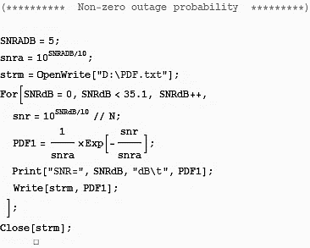

**6. Program for cumulative distribution function of γ**

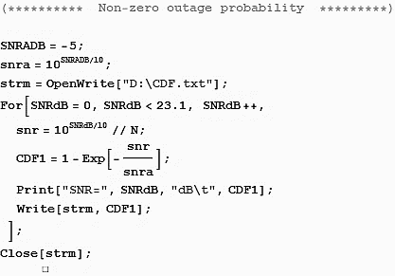

**7. Program for moment generation function of $γ$**

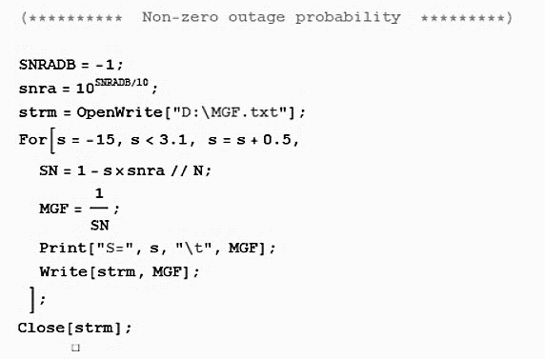

**8. Numerical results of probability density function of γ**

1. **Numerical data**

**b) Graphical representation**

**Figure 1.1.** Probability Density Function vs Signal to Noise Ratio plot for Rayleigh fading SISO channel.

**(b) Description of Figure 1.1:** This is a plot of the probability density function (***PDF***) vs signal-to-noise ratio (***SNR*** or ***g***) for various values of the average SNR (SNRADB). This graph depicts the impact of SNR on PDF.

The graph above demonstrates that as the SNR value increases, the PDF value falls. The rate at which the PDF value falls is determined by the average SNR value. When the SNRADB value is lower (e.g., 5) the PDF value declines faster than when the SNRADB value is larger (e.g., 10 or 15). When the SNR is low, noise dominates the received signal, and the fading envelope undergoes deep fades.

**9. Numerical results of cumulative distribution function of γ**

**a) Numerical data**



**b) Graphical representation**

**Figure 1.2.** Cumulative Distribution Function vs Signal to Noise Ratio plot for Rayleigh fading SISO channel.

**c) Description of Figure 1.2:** This is a visualization of the cumulative distribution function (***CDF***) vs signal-to-noise ratio (***SNR*** or ***g***) for a certain average value of SNR (***SNRADB***). This graph depicts the impact of SNR on CDF.

The CDF vs. SNR graph shows the cumulative chance of encountering various fading envelope values at different Signal to Noise Ratio (***SNR***) levels. For example, if the CDF value at SNR = 10 dB is 0.8, it means that there is an 80% chance that the fading envelope R is smaller than or equal to r at SNR = 10 dB, where the fading envelope is denoted as R and its cumulative distribution function (CDF) as FR(r). The following trends were detected in the CDF vs. SNR graph:

The CDF climbs slowly and steadily at low SNR levels, indicating a larger likelihood of meeting small fading envelope values. As SNR grows, the slope of the CDF becomes steeper, indicating a lower likelihood of encountering small envelope values.

**10. Numerical results of moment generation function of γ**

**a) Numerical data**



**b) Graphical representation**

**Figure 1.3.** Moment Generation Function vs Variable (***s***) plot for Rayleigh fading SISO channel.

**c) Description of Figure 1.3:** This is a visualization of the Moment Generating Function (***MGF***) as a function of variable ***s*** for a given value of SNR average (***SNRADB***). This graph depicts the impact of SNR on MGF. The graph above demonstrates that as the "s" value increases, so does the MGF value. The rate of growth of the MGF value at the negative section of s is determined by the average SNR value. When SNRADB (e.g., -5) is small, the MGF value increases slower than when SNRADB is greater (e.g., -3 or -1), but in the positive portion of s, the situation is completely reversed.

**11. Discussion and Conclusion**

**a) Discussion:** The peak MGF value at 0 dB is determined by the average SNR value. The initial value of MGF (at 0 dB) was higher at lower SNRADB values than at higher SNRADB values.

……………

For the Rayleigh Fading SISO channel amount of fading is unity and independent of SNR.

**b) Conclusion:** From our investigation, we can draw the following conclusions:

…………..

Finally, comprehending the statistical features of the Rayleigh-fading SISO channel as revealed by the PDF, CDF, and MGF analyses is critical for building robust and efficient digital communication systems.